Nathan Hale
New York Times best-selling
author/illustrator
Widely known for Hazardous Tales series

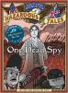
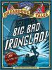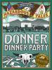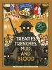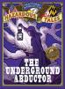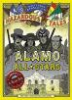
Circle cover(s) you want

Purchase a Hazardous Tale for
Nathan Hale’s autograph…
$14 each (tax included)
Payable by CASH or CHECK
made out to Coble PTA

_______ total books X $14.00 each = $_________ total

